CICD Setup
Jenkins
Install Jenkins and Setup
Create a Build JOB in Jenkins: Create a project
SonarQube
Install sonarQube server
Connect SonarQube to Jenkins
Jenkins & Bitbucket
Link your Jenkins project to your Source Code: Jenkins & Bitbucket
Adding Credentials
Trigger Build on commit
Android
Jenkins build for Android
SonarQube for Android
Jenkins and SonarQube for Android
Fastlane for Android
Install fastlane
Collect your Google credentials
Configure supply
Fetch your app metadata
Set up environment variables
Deploy to Google Play using fastlane
Building your app
Uploading your APK
Web
Jenkins build for Web
Jenkins and SonarQube for Web
Jenkins Deploy for web

CICD Setup

Jenkins

Install Jenkins and Setup
- Install on macOS:
  - To install from the website, using a package:
  - Download the latest package
  - Open the package and follow the instructions
- Jenkins can also be installed using brew:
  - Install the latest release version
    - brew install jenkins
  - Install the LTS version
    - brew install jenkins-lts
- Unlock : After running jenkins and accessing the localhost:8080 page, if you see the unlock screen:
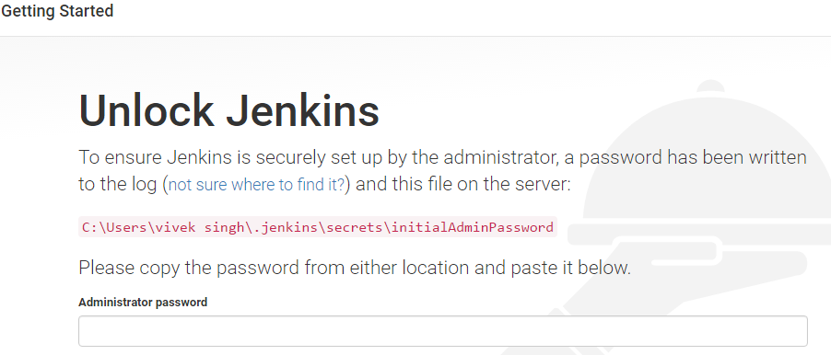
Follow the instructions here : https://www.youtube.com/watch?v=_7LaeqKAHvA
  - Open the secrets folder shown in the screen
  - Right click on the Folder->Info
  - Add your user to the permission box
- Follow the wizard, install suggested plugins…
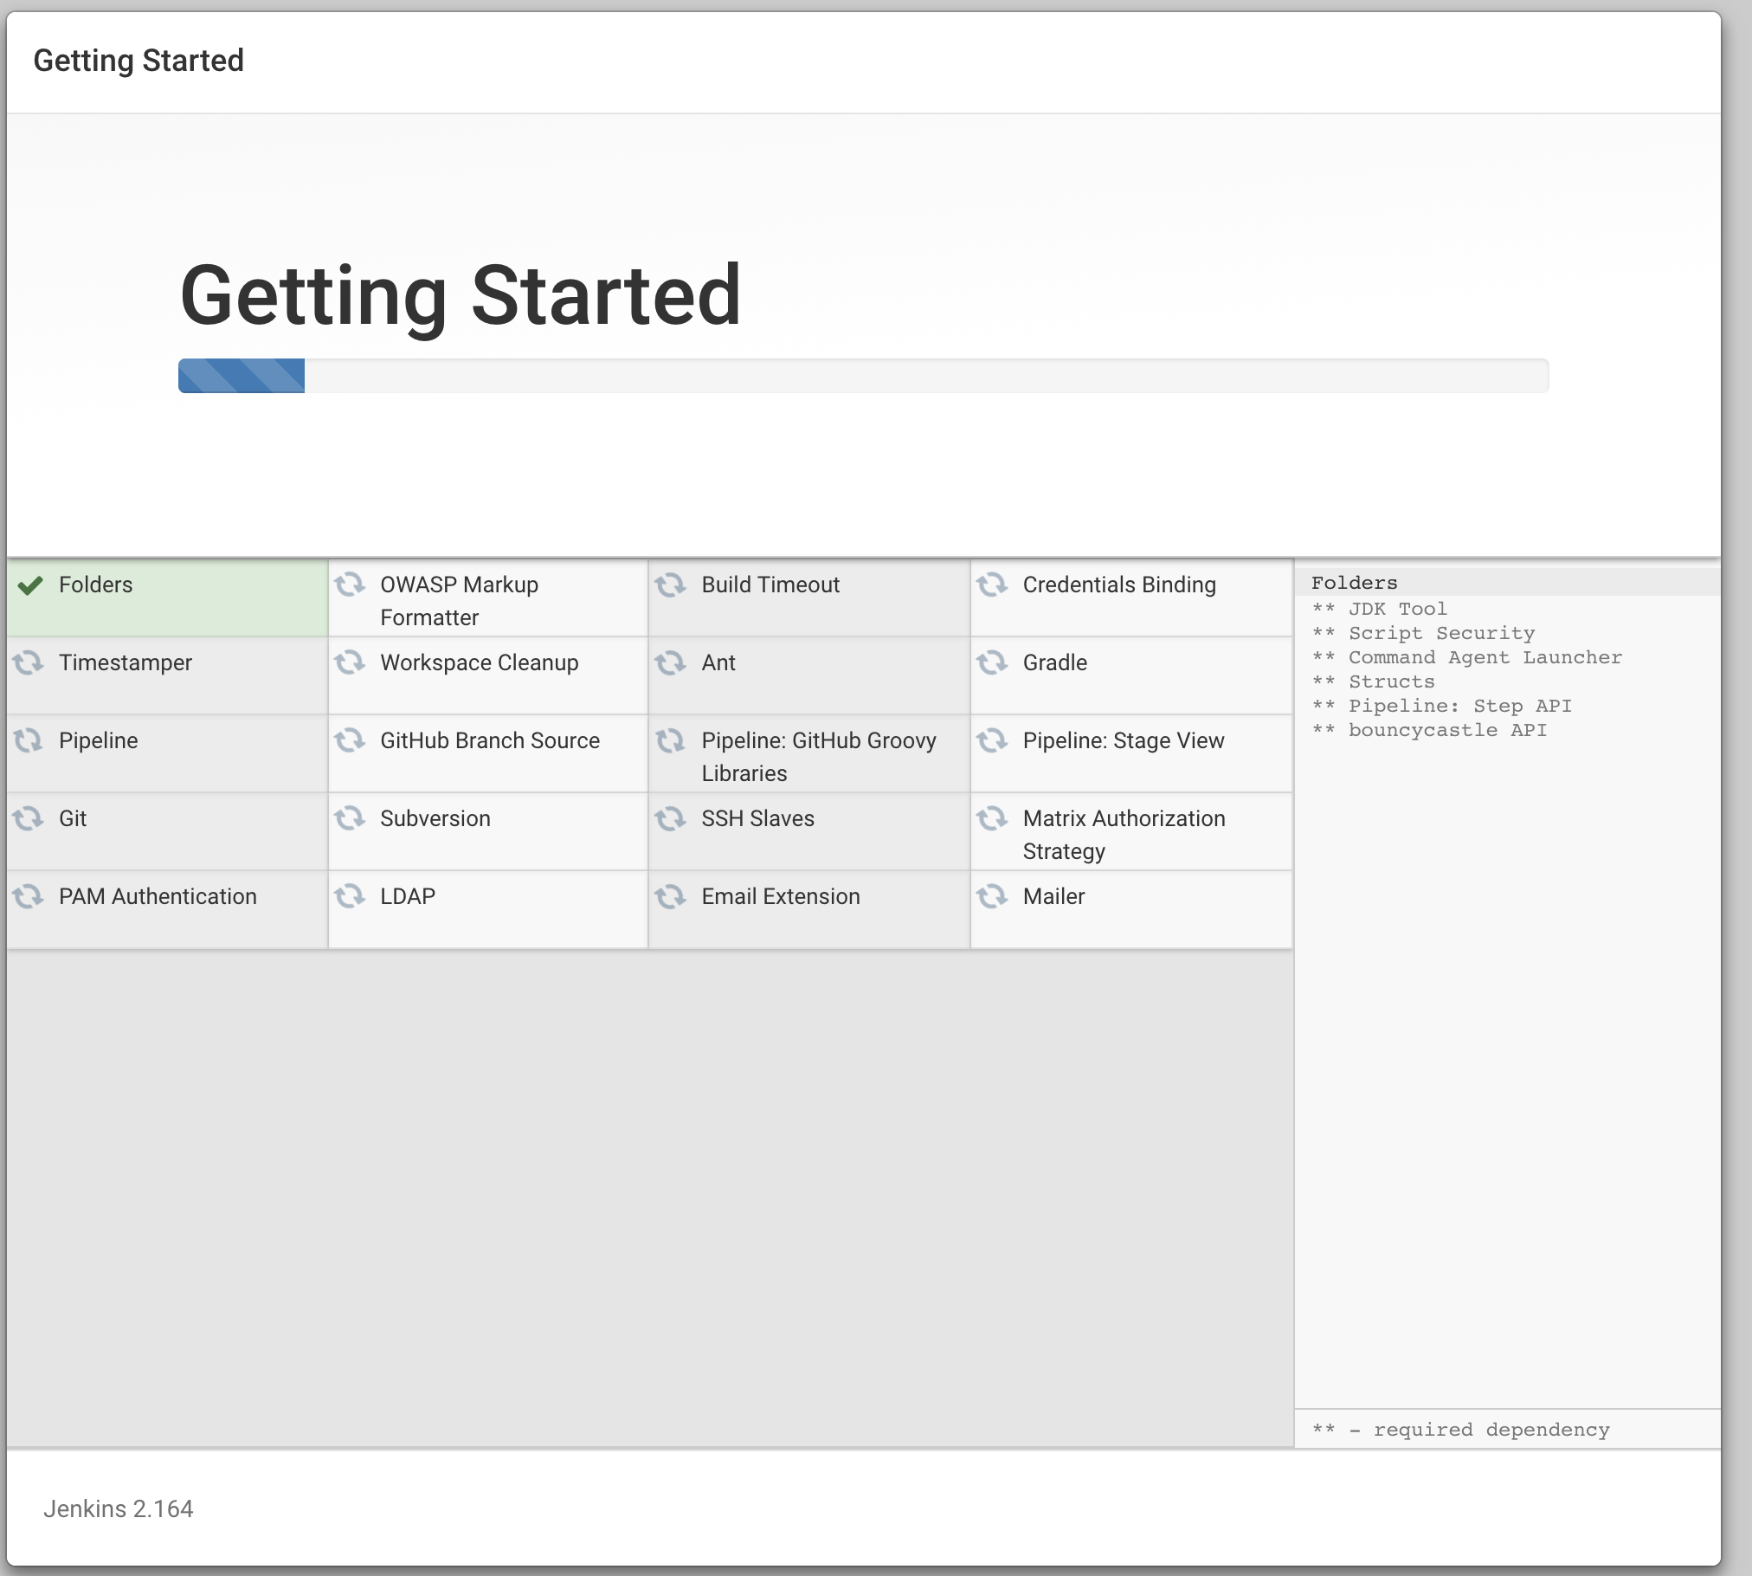

Create a Build JOB in Jenkins: Create a project
- Prerequisites:
  - Make sure Jenkins is started, if not run inside the Jenkins folder:
java -jar jenkins.war --httpPort=9090
  - Note,to stop jenkins: In your browser go to : [Jenkins-URL]/exit
- Create a Job:
  - Click on the create job button
  - Choose: Freestyle project
  - Name your project

SonarQube

Install sonarQube server
- Download the SonarQube Community Edition
- Unzip it, let's say in C:\sonarqube or /opt/sonarqube
- Start the SonarQube Server:
  - cd sonarqube-7.6/
  - ./bin/macosx-universal-64/sonar.sh start
- Access it at : localhost:9000

Connect SonarQube to Jenkins
- Add the sonarqube plugin to Jenkins:
  - Jenkins home → Manage Jenkins → Manage plugins
  - Go to available tab, and search for Sonar
  - Locate plugin:
SonarQube Scanner
  - And download and restart

Jenkins & Bitbucket

Link your Jenkins project to your Source Code: Jenkins & Bitbucket
- From your jenkins page go to the project page
- Go to Configure
- Click on the : Source Code Management tab
  - Choose Git
  - Enter your URL
  - Choose your credentials (Check next section to know how to add credentials)
  - Specify the branch
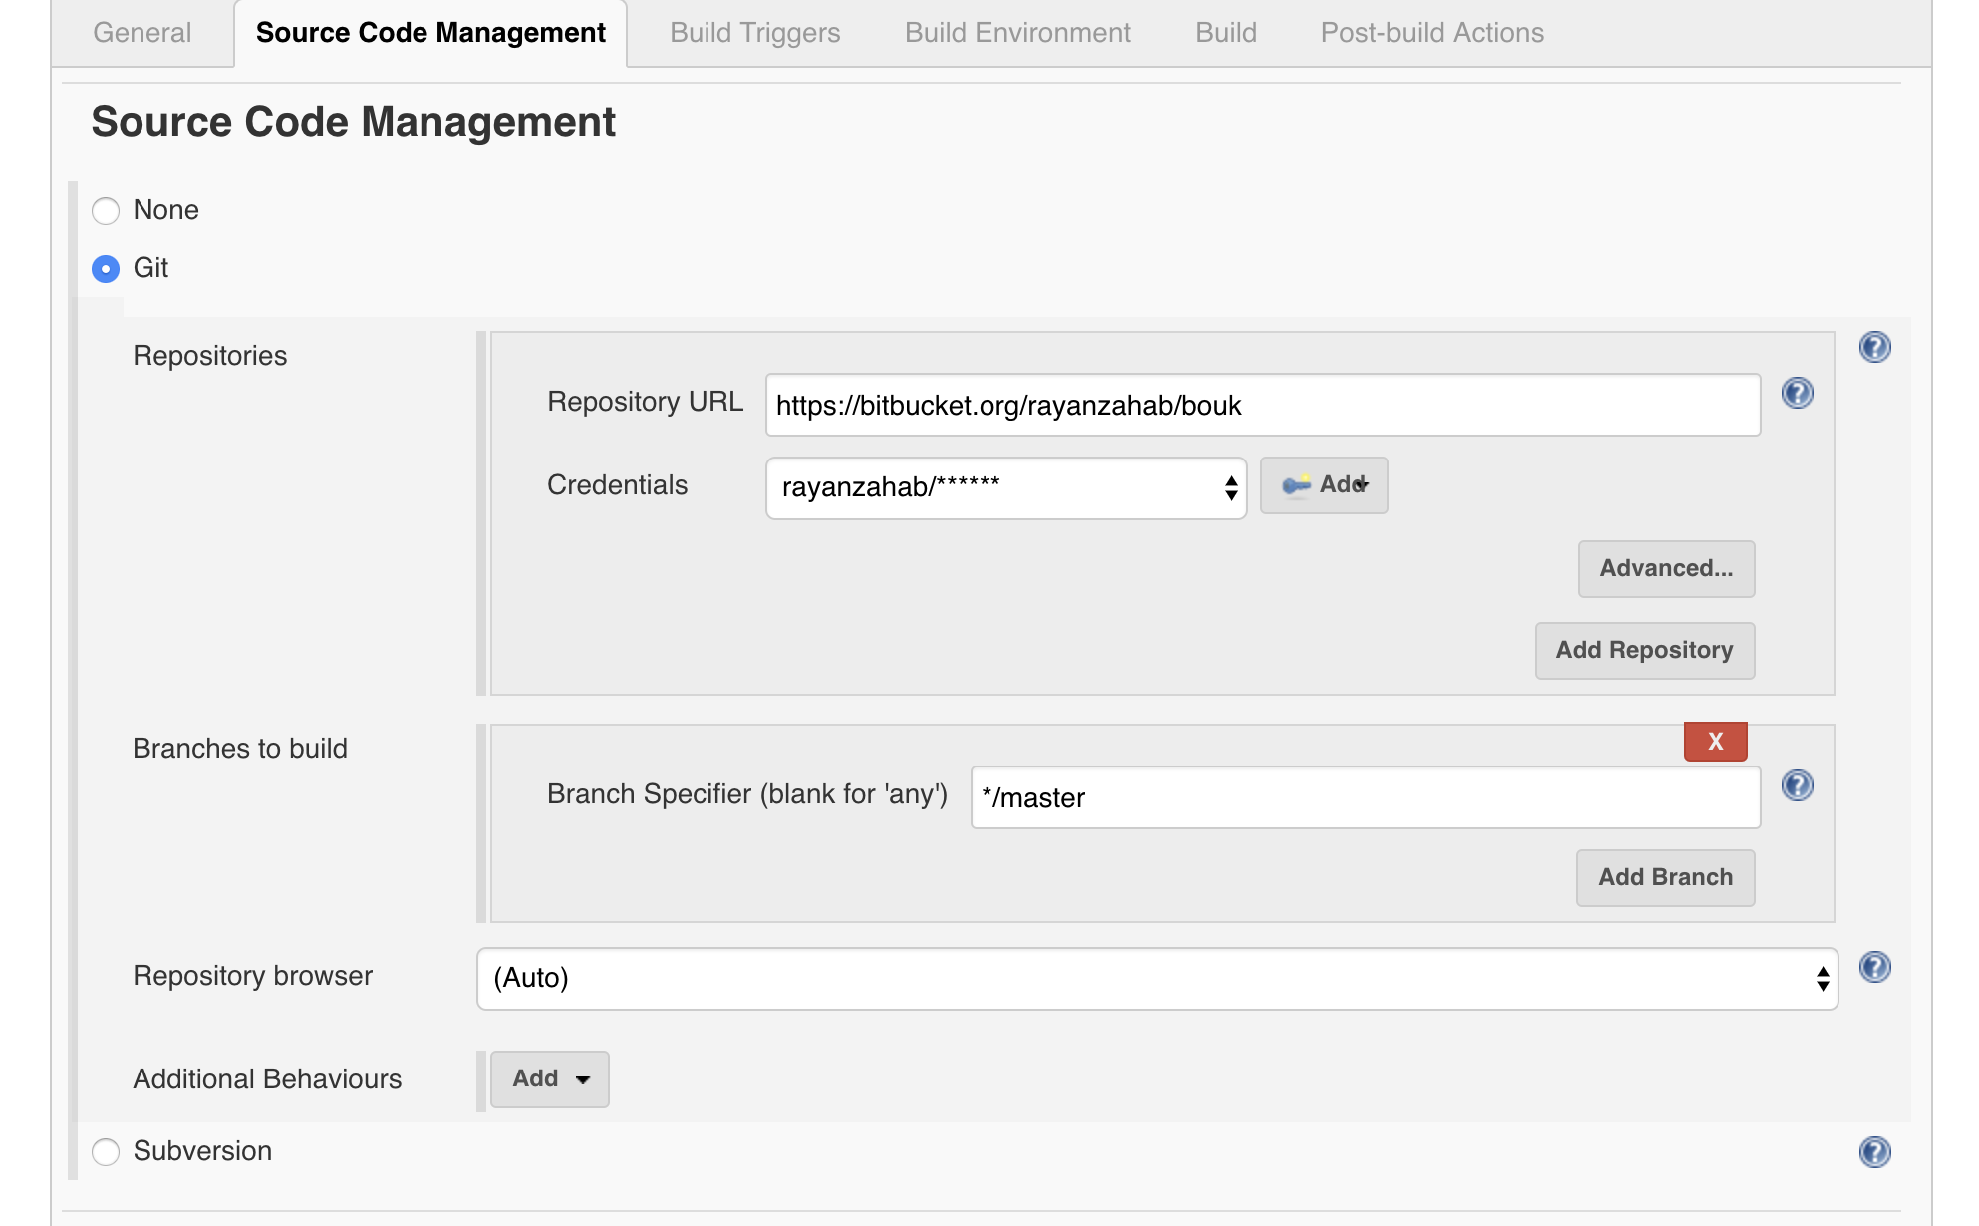

Adding Credentials
- click the Add button to create the credential
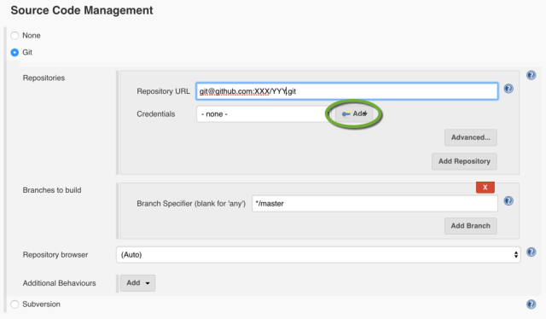
- Click Jenkins to select the credentials provider
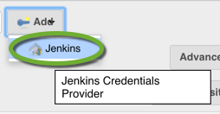
- Select SSH Username with private key as the Kind
- Enter the username you used when you created the SSH key for the Git repository
- Select From the Jenkins master ~/.ssh as the Private Key
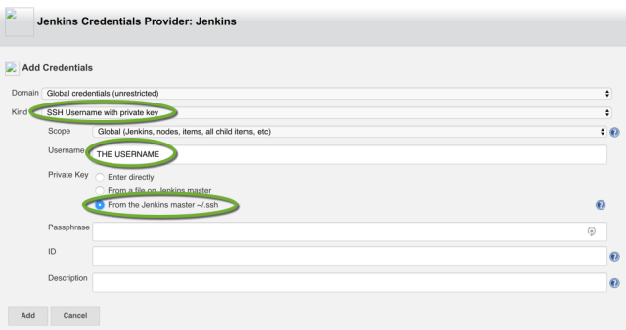
- Click the Add button
- Now you will be able to see these credentials under the drop down.
- In the Credentials drop down select the credential you have created (the Git user name)
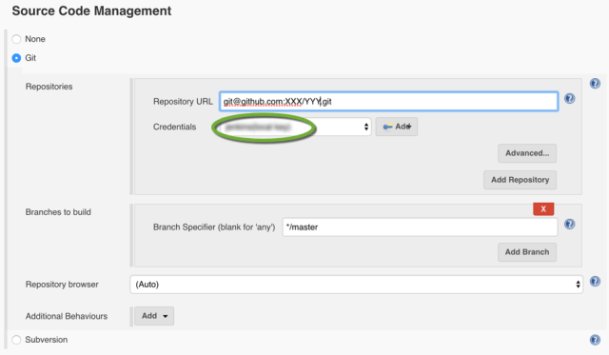

Trigger Build on commit
- Go to the Build Triggers tab under the project:
- Check Poll SCM to trigger build after commits to your chosen branch
- Specify when to check for changes using the syntax of cron :
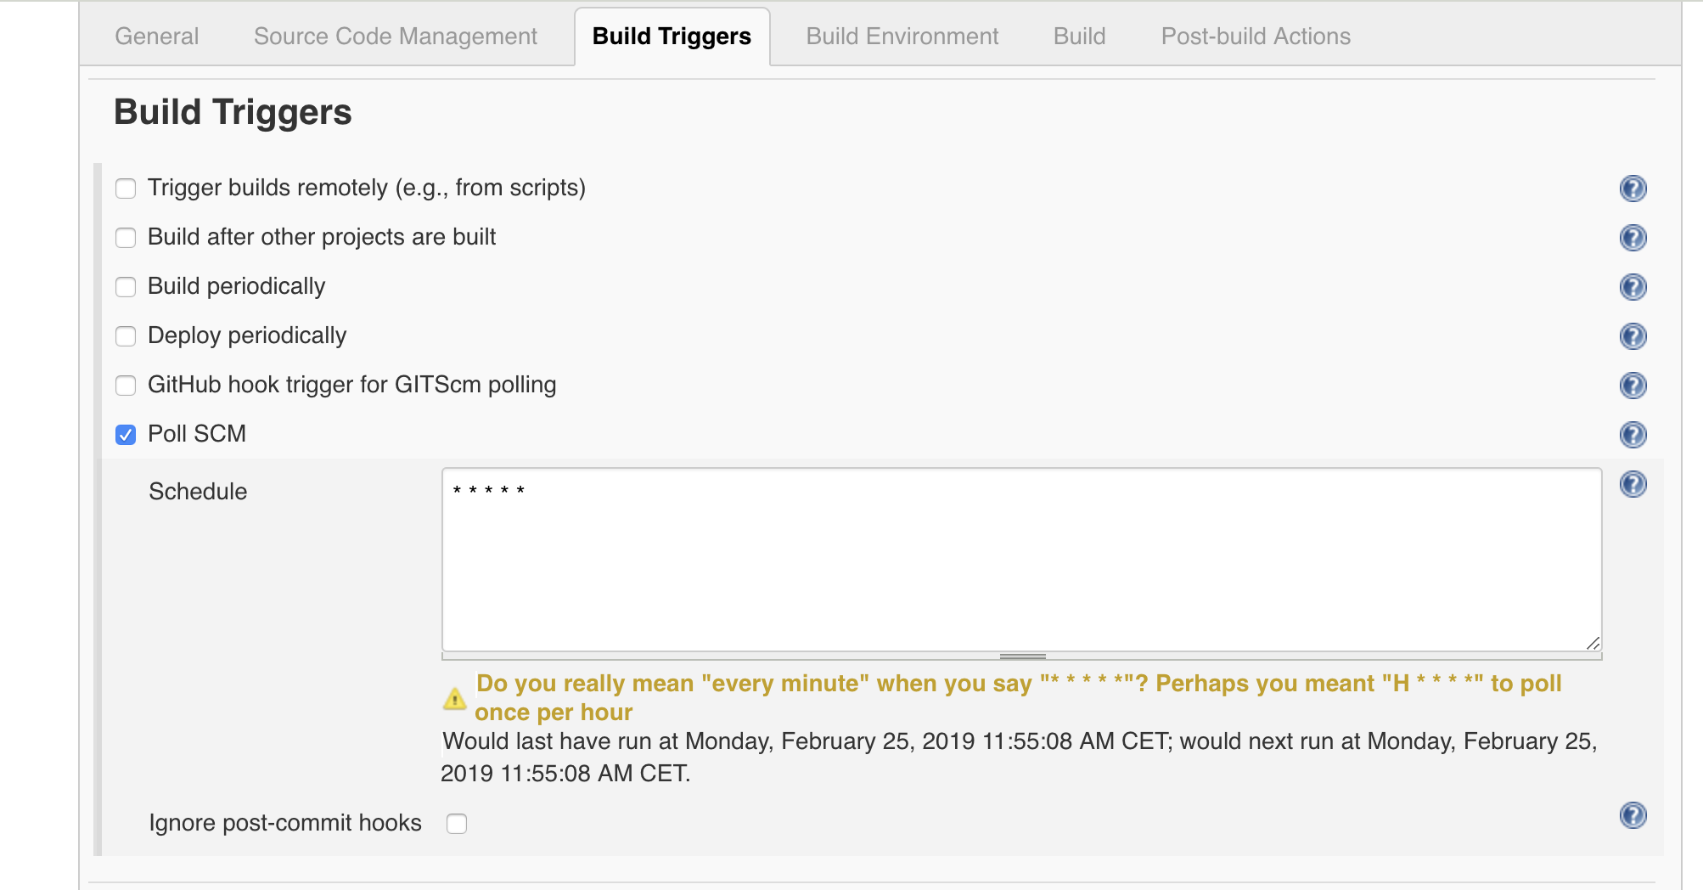

Android

Jenkins build for Android
If your project is an android application:
- Go to Build Tab
- Check Gradle Wrapper (If you would like to use gradlew instead of gradle)
- Specify your workspace location
  - Usually Jenkins has a defined variable for where it put the codes after pulling from your git repo when a build is triggered: $(workspace)/
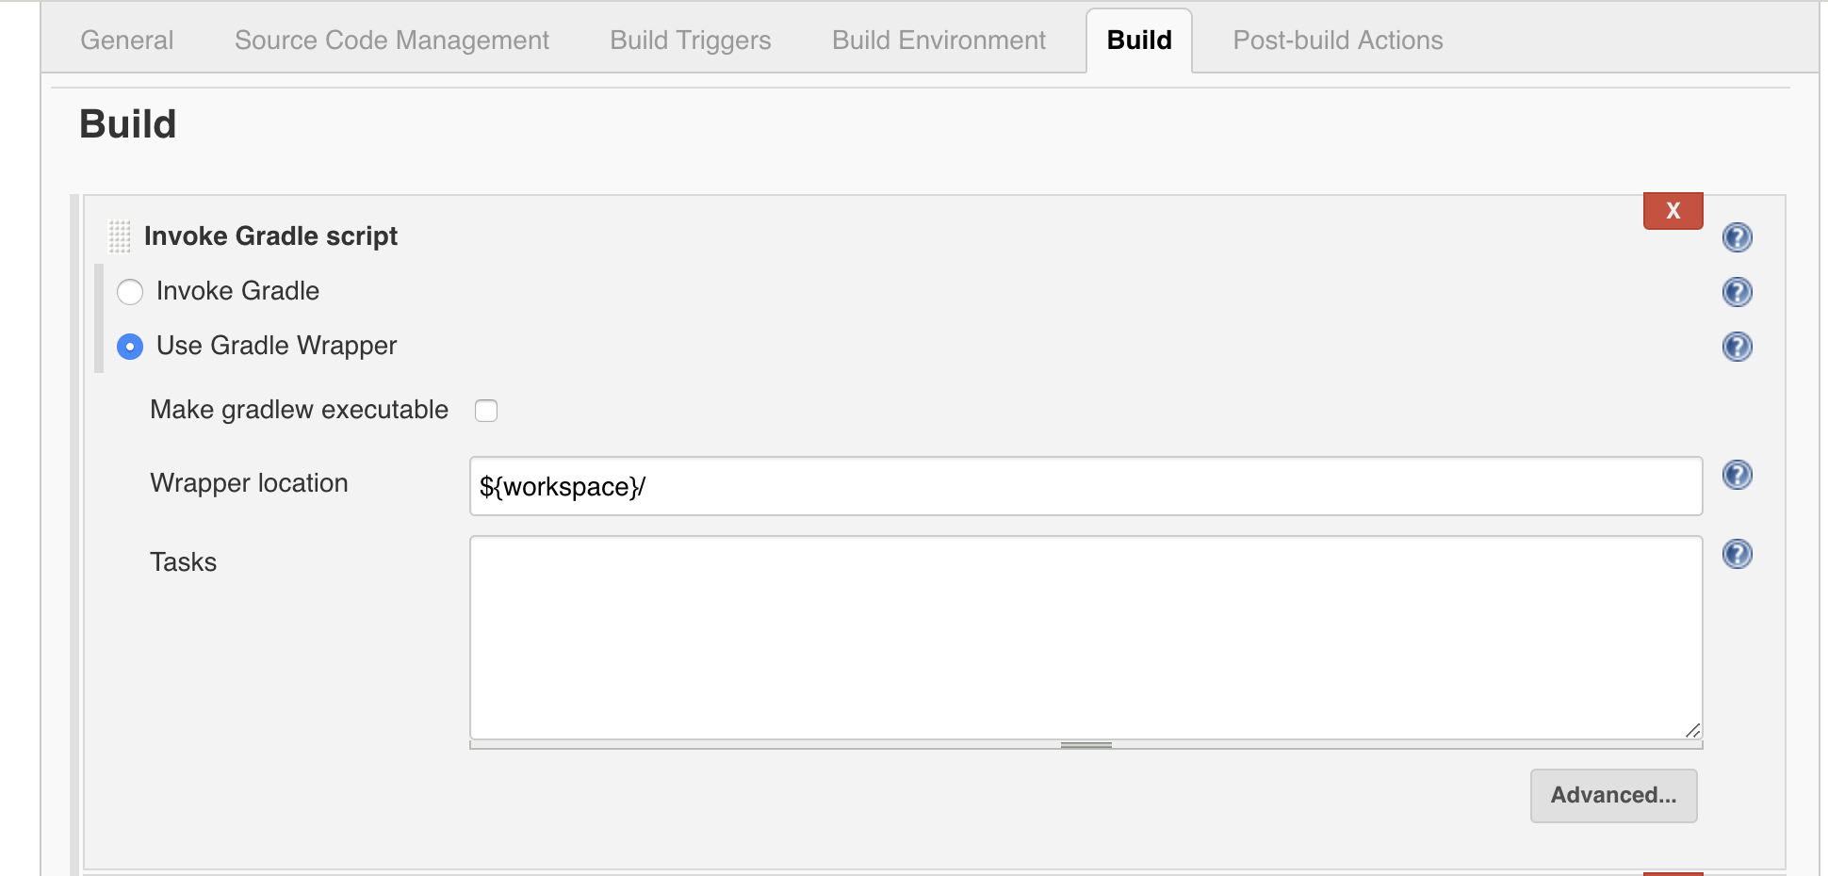
If you have lint and unit tests setup in your project you can also ask the build to run them by adding the commands under tasks:
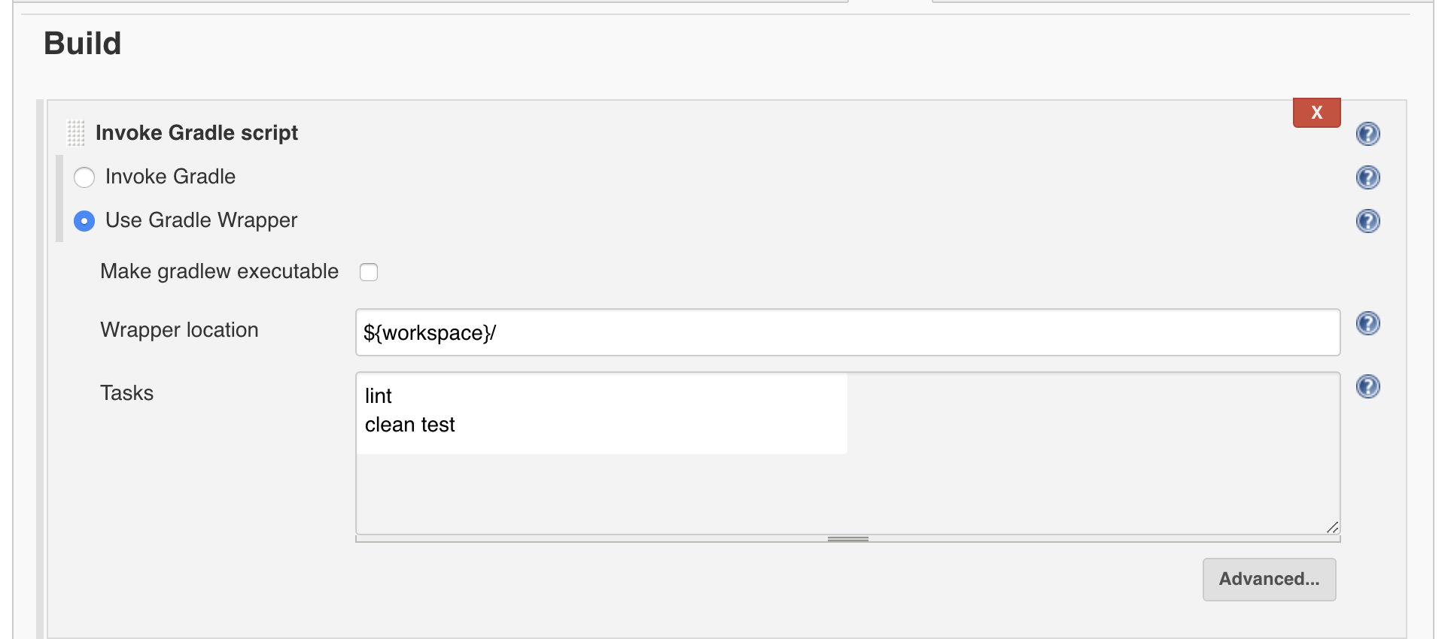

SonarQube for Android
To send the Android code to SonarQube you need to setup the prerequisites below.
- Ensure Android SDK Platform 27 is installed or update the app/build.gradle with the SDK version you have installed. To instal SDK platform 27 go to Android Studio -> Preferences -> Appearance & Behavior -> System Settings -> Android SDK and check the Android 8.1 (Oreo) then click Ok.
- Add the following to your project buildscript
buildscript {
dependencies {
classpath 'org.sonarsource.scanner.gradle:sonarqube-gradle-plugin:2.7'
}
}
- Apply the plugin from your build.gradle:
apply plugin: 'org.sonarqube'
- Define the sonarqube rules and resources in your build.gradle:
Make sure you update the sonar.login : Go to your sonar link, Admin->security and generate a token.
sonarqube {
properties {
property "sonar.host.url", "http://localhost:9000"
property "sonar.login", "75eeb35bb22e4be73769d08598db477ada40c6ae"
def libraries = project.android.sdkDirectory.getPath() + "/platforms/android-27/android.jar," +
"build/intermediates/classes/*"
property "sonar.projectVersion", System.getenv("BUILD_NUMBER")
property "sonar.sourceEncoding", "UTF-8"
property "sonar.sources", "src/main/java"
property "sonar.binaries", "build/intermediates/classes/*"
property "sonar.libraries", libraries
property "sonar.java.binaries", "build/intermediates/classes/*"
property "sonar.java.libraries", libraries
property "sonar.tests", "src/test/java" // where the tests are located
property "sonar.java.test.binaries", "build/intermediates/classes/*"
property "sonar.java.test.libraries", libraries
property "sonar.scm.provider", "git"
property "sonar.jacoco.reportPaths", "build/jacoco/testDebugUnitTest.exec"
property "sonar.jacoco.reportPaths", "build/jacoco/testDebugUnitTest.exec, build/spoon/mock/debug/coverage/merged-coverage.ec"
// path to coverage report
property "sonar.java.coveragePlugin", "jacoco"
property "sonar.junit.reportsPath", "build/test-results/testDebugUnitTest"
// path to junit reports
property "sonar.android.lint.report", "build/reports/*.xml"
// path to lint reports
}
}

- Run the following command from the project root folder
./gradlew --info sonarqube
- Access the report from the link provided in the command line , or simply access your sonar dashboard on go to your project.

Jenkins and SonarQube for Android
- Invoke running sonar after build:
  - Go to configure inside the project
  - Go to build tab
  - Under add build setup choose: Execute SonarQube Scanner
  - Provide the properties as shown below:
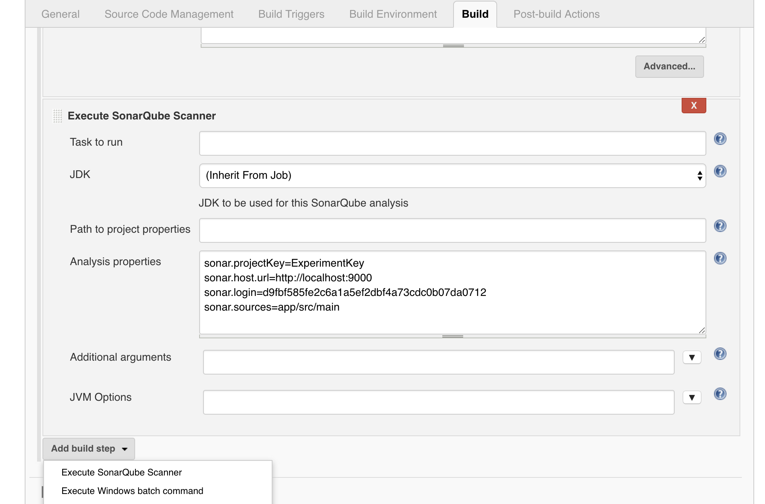

Now the sonarqube scanner will be invoked after every build.

Fastlane for Android

Install fastlane
  - Make sure you have the latest version of the Xcode command line tools installed:
xcode-select --install
  - Install fastlane using
[sudo] gem install fastlane -NV
  - or alternatively using brew cask install fastlane
- Setup: https://docs.fastlane.tools/getting-started/android/setup/
- Test by running pre existing actions:
fastlane env
- Deploy using fastlane: https://docs.fastlane.tools/getting-started/android/setup/

Collect your Google credentials
Tip: If you see Google Play Console or Google Developer Console in your local language, add &hl=en at the end of the URL (before any #...) to switch to English.
- Open the Google Play Console
- Click the Settings menu entry, followed by API access
- Click the CREATE SERVICE ACCOUNT button
- Follow the Google Developers Console link in the dialog, which opens a new tab/window:
  - Click the CREATE SERVICE ACCOUNT button at the top of the Google Developers Console
  - Provide a Service account name
  - Click Select a role and choose Service Accounts > Service Account User
  - Check the Furnish a new private key checkbox
  - Make sure JSON is selected as the Key type
  - Click SAVE to close the dialog
  - Make a note of the file name of the JSON file downloaded to your computer
- Back on the Google Play Console, click DONE to close the dialog
- Click on Grant Access for the newly added service account
- Choose Release Manager from the Role dropdown
- Click ADD USER to close the dialo

Configure supply
Edit your fastlane/Appfile and change the json_key_file line to have the path to your credentials file:
json_key_file "/path/to/your/downloaded/key.json"

Fetch your app metadata
If your app has been created on the Google Play developer console, you're ready to start using supply to manage it! Run:
fastlane supply init
and all of your current Google Play store metadata will be downloaded to fastlane/metadata/android.
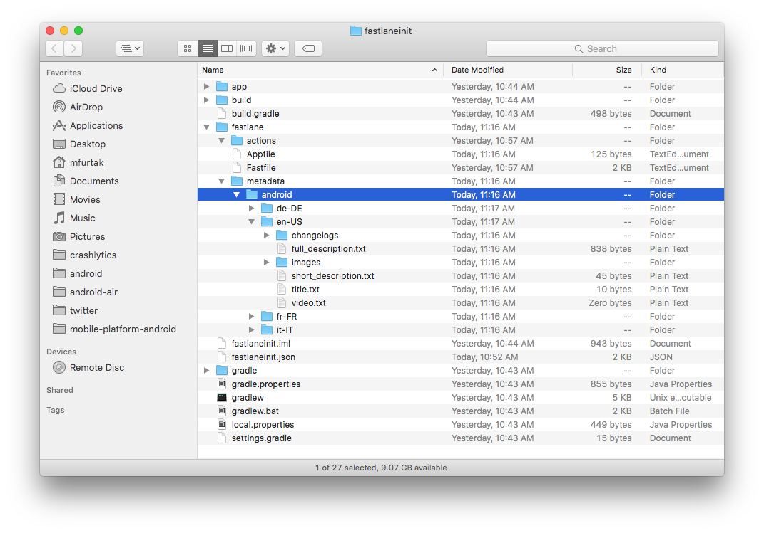
Due to limitations of the Google Play API, supply can't download existing screenshots or videos.

Set up environment variables
fastlane requires some environment variables set up to run correctly. In particular, having your locale not set to a UTF-8 locale will cause issues with building and uploading your build. In your shell profile add the following lines:
export LC_ALL=en_US.UTF-8
export LANG=en_US.UTF-8
You can find your shell profile at ~/.bashrc, ~/.bash_profile, ~/.profile or ~/.zshrc depending on your system.

Deploy to Google Play using fastlane

Building your app
fastlane takes care of building your app by delegating to your existing Gradle build. Just add the following to your Fastfile:
lane :playstore do
gradle(
task: 'assemble',
build_type: 'Release'
)
end
Try running the lane with:
fastlane playstore
When that completes you should have the appropriate APK ready to go in the standard output directory. To get a list of all available parameters for the gradle action, run:
fastlane action gradle

Uploading your APK
To upload your binary to Google Play, fastlane uses a tool called supply. Because supply needs authentication information from Google, if you haven't yet done the supply setup steps, please do those now!
With that done, simply add a call to supply to the lane you set up above:
lane :playstore do
gradle(
task: 'assemble',
build_type: 'Release'
)
upload_to_play_store # Uploads the APK built in the gradle step above and releases it to all production users
end
This will also: - Upload app metadata from fastlane/metadata/android if you previously ran fastlane supply init - Upload expansion files (obbs) found under the same directory as your APK as long as: - They are identified by type as main or patch by containing main or patch in their file names - There is at most one of each type - Upload screenshots from fastlane/metadata/android if you previously ran screengrab - Create a new production build - Release the production build to all users
If you would like to capture and upload screenshots automatically as part of your deployment process, check out the fastlane screenshots for Android guide to get started!
To gradually roll out a new build you can use:
lane :playstore do
# ...
upload_to_play_store(
track: 'rollout',
rollout: '0.5'
)
end
To get a list of all available parameters for the upload_to_play_store action, run:
fastlane action upload_to_play_store

Web

Jenkins build for Web
If your project is an android application:
- Go to Build Tab
- Choose: Execute shell
- Build the war file : jar cvf mathweb-$BUILD_NUMBER.war .
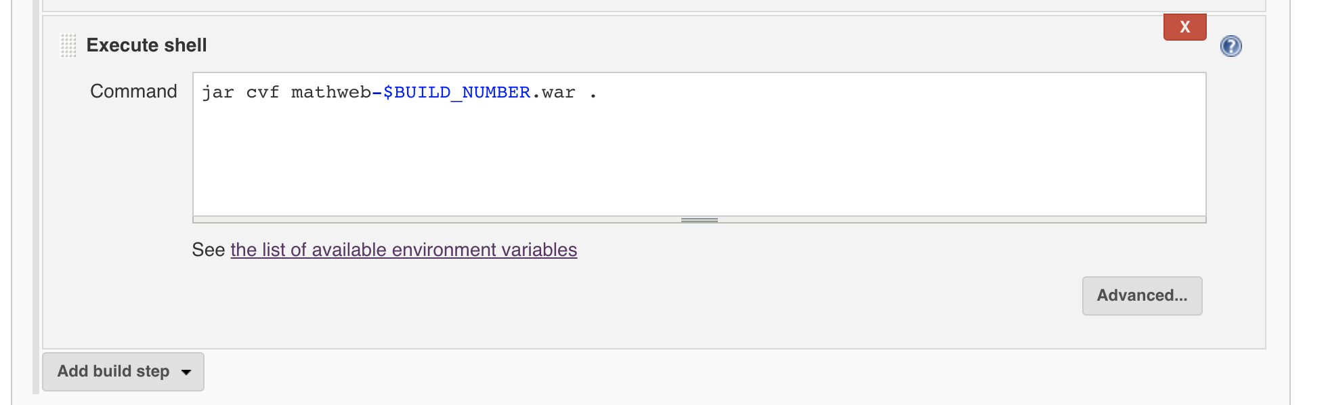

Jenkins and SonarQube for Web
Invoke running sonar after/before build:
  - Go to configure inside the project
  - Go to build tab
  - Under add build setup choose: Execute SonarQube Scanner
  - Provide the properties as shown below:
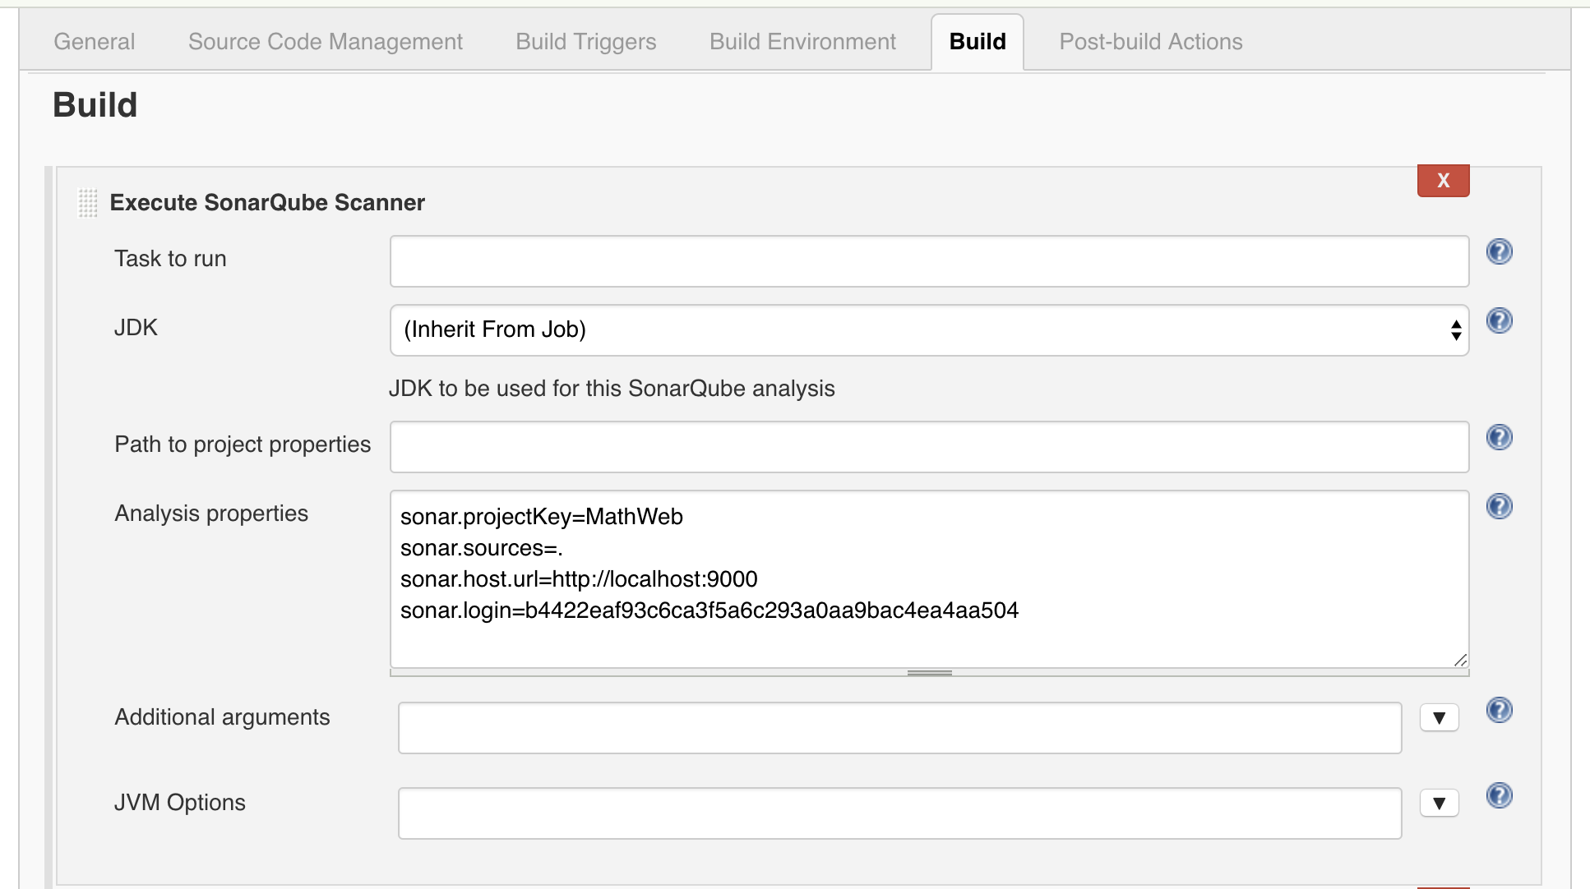

Now the sonarqube scanner will be invoked after every build.

Jenkins Deploy for web
Deploy the web application to a Tomcat server after build:
- Go to the Post-build Actions tab inside the project’s configure page
- From the Add post-build action drop down choose: Deploy war/ear to a container
- Add the details as below:
- Make sure to add the tomcat credentials to allow deploying
